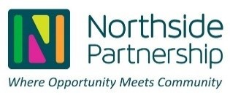

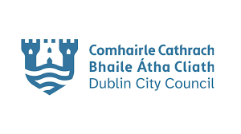
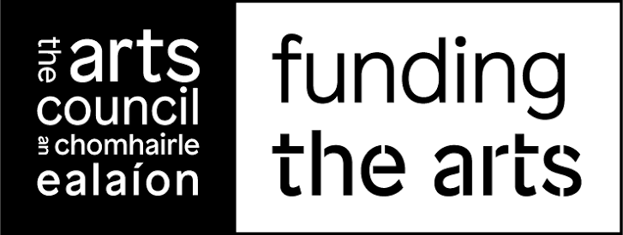


Creative Places Darndale – Arts Project Funding Application Form
Creative Places Darndale, administered by Northside Partnership, supports local artists, community groups, and individuals to develop and deliver creative projects that engage the Darndale community.

1. Applicant Details
Name of Individual / Group:
________________________________
Contact Person (if group):
________________________________________
Address:
________________________________________
Phone Number:
________________________________________
Email Address:
________________________________________

2. Project Overview
Project Title:
________________________________________
Artform/Discipline (e.g. visual arts, music, theatre):
________________________________________
Brief Description of Project (max 200 words):
________________________________________

3. Community Engagement
Who will benefit from this project?
________________________________________
How will the local community be involved?
________________________________________
Estimated number of participants/audience:
________________________________________

4. Project Delivery
Proposed Start Date:
________________________________________
Proposed End Date:
________________________________________
Location(s) of Project:
________________________________________
Key activities and timeline:
________________________________________

5. Budget
Total Project Cost (€):
________________________________________
Amount Requested from Creative Places Darndale (€):
________________________________________
Details of Expenditure (materials, artist fees, etc.):

- Please breakdown the projected cost into a table with as much detail as possible .

Other funding sources (if any):
________________________________________

6. Experience
Please outline any relevant experience in delivering arts or community projects:
________________________________________

7. Supporting Information
Please list any additional documents attached (if applicable):

Please outline if the Artist has their own Insurance ____ ____
YES No
Artists might want to include the cost of securing insurance into their proposal

8. Declaration
I confirm that the information provided is accurate and that I agree to the terms and conditions of the programme.
________________________________________
Name:
________________________________________
Signature:
________________________________________
Date:
________________________________________

Creative Places Darndale – Application Completion Guidelines
These guidelines support applicants in completing the funding application form correctly and in line with the assessment and approval process.

1. General Guidance
- Read all sections carefully before completing the form
- Complete all required sections in full; incomplete applications may be deemed ineligible
- Keep responses clear, concise, and relevant (especially where word limits apply)
- Submit the application before the stated deadline; late submissions will not be accepted
- Applicants are encouraged to engage with Smashing Times (Programme Coordinators) for support before submission

2. Section-by-Section Guidance
Section 1: Applicant Details
- Provide accurate contact information
- For groups, clearly identify the lead contact person responsible for the project

Section 2: Project Overview
- Clearly describe:
  - What the project is
  - What artform(s) are involved
  - The purpose and intended outcomes
- Ensure your project aligns with:
  - Creativity and artistic activity
  - Benefit to the Darndale/Belcamp/Moatview/Priorswood community
  - the intended outcomes (skills development, community connection, artistic output)?
  - Who are the intended target group. (older adults, youth etc)
  - are there any other collaborators on this project and if so please list.
  - Safeguarding, if working with young people or vulnerable adults, child protection guidelines must be adhered too.
  - If it is filming that the right permits / permissions are given ?
  - Is the appropriate insurance in place for this proposed project?

Section 3: Community Engagement
- Clearly identify:
  - Who will participate or benefit
  - How people will actively engage (not just attend)
- Provide realistic estimates for participant numbers
- Strong applications demonstrate meaningful engagement, not passive delivery

Section 4: Project Delivery
- Provide a clear and realistic timeline
- Include:
  - Start and end dates
  - Key milestones or activities
  - Project locations
- Ensure feasibility — unrealistic timelines may affect assessment scoring

Section 5: Budget
- Provide a detailed, realistic, and balanced budget
- Include:
  - Artist fees
  - Materials
  - Production costs
- Ensure:
  - Costs are reasonable and justified
  - Funding requested aligns with project scope
- Clearly list any additional funding sources
Applications are assessed on value for money and feasibility

Section 6: Experience
- Outline relevant experience in:
  - Arts projects
  - Community engagement
- If experience is limited, demonstrate:
  - Support structures
  - Partnerships
  - Willingness to engage with coordinator support

Section 7: Supporting Information
- Include only relevant documents, such as:
  - CVs
  - Portfolios
  - Letters of support
- Do not overload the application with unnecessary material

Section 8: Declaration
- The declaration confirms:
  - Accuracy of information
  - Acceptance of funding conditions
- Unsigned forms will not be accepted

3. Assessment Alignment Tips
Applications are assessed based on:
- Community impact
- Artistic quality
- Feasibility
- Value for money
- Alignment with programme priorities
💡 Tip: Strong applications clearly address all five areas throughout the form.

4. Pre-Submission Support
Applicants are strongly encouraged to:
- Seek feedback from Smashing Times (CPD Coordinators)
- Submit draft ideas for guidance before applying
This reflects the development support stage of the process

Creative Places Darndale – Terms & Conditions of Funding
These terms apply to all successful applicants and form part of the funding agreement.

1. Use of Funding
- Funding must be used only for the approved project and agreed activities
- Expenditure must align with the approved budget
- Any significant changes require prior written approval from Smashing Times

2. Funding Agreement
- Successful applicants must sign a Grant Agreement before funds are released
- This will outline:
  - Payment schedule
  - Approved activities
  - Reporting requirements

3. Payment of Funds
- Payments may be made: ( to be discussed upon approval )
  - In instalments, or
  - Upon completion (depending on project scale)
- Final payments are conditional on satisfactory reporting and compliance

4. Financial Accountability
Recipients must:
- Maintain accurate financial records
- Provide:
  - Receipts
  - Invoices
  - Proof of payments
- Return any unspent or ineligible funds

5. Project Delivery
- Projects must:
  - Be delivered as outlined in the approved application
  - Take place within the agreed timeline
- Any delays or issues must be communicated promptly

6. Monitoring & Support
- Smashing Times (Coordinators) will:
  - Monitor progress
  - Provide guidance and support during delivery
- Recipients must cooperate with reasonable requests for updates

7. Reporting Requirements
A Final Report is mandatory and must include:
- Description of activities delivered
- Evaluation of outcomes and community impact
- Financial report with supporting documentation
Failure to submit may affect future funding eligibility

8. Acknowledgement & Publicity
All funded projects must acknowledge:
- Creative Places Darndale
Acknowledgement must appear in:
- Printed materials
- Social media
- Public communications

9. Insurance & Compliance
Recipients are responsible for:
- Public liability insurance (where applicable)
- Health and safety compliance
- Child protection and safeguarding (if relevant)

10. Changes to Project
- Any changes to:
  - Budget
  - Timeline
  - Activities
must receive prior written approval
Unapproved changes may result in funding withdrawal

11. Right to Withhold or Recover Funding
Creative Places Darndale reserves the right to:
- Withhold payments
- Request repayment of funding
In cases of:
- Non-compliance
- Misuse of funds
- Failure to deliver the project as agreed

12. Data & Documentation
- Project information may be used for:
  - Reporting
  - Evaluation
  - Promotional purposes

13. Future Funding Eligibility
Failure to comply with programme requirements may:
- Affect eligibility for future Creative Places Darndale funding rounds

